READY HF MATH SUCCESS!
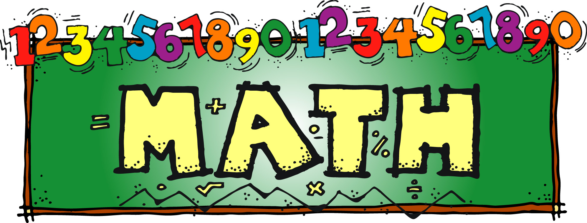

Miss Dornbos Math Class Information

- Walk into classroom down the middle line and walk to your seat.
- Voice Level=1=Spy Talk=whispering only=one person can hear you.
- Put materials quietly down on top of your desk.
- Stand behind your chair.
- Sign of the cross
- EAST WALL CHANT
- WEST WALL CHANT
- NUMBER MULTIPLES CHANT
- Sign of the Cross
- Please be seated
- MD GREETS CLASS
- CLASS GREETS MD

Class Format:
- BELL WORK
- Previous night’s homework check, questions, collect
- MINI LESSON OF THE DAY
- OFF TO WORK/DISCOVER STUDENTS GO

Math Supplies:
- Textbook
- Composition Book
- Binder
- Homework Planner
- Loose Leaf Paper=wide rule
- One blue folder=two pocket, 3 hole punch
- Ruler
- Calculator
- Number 2 pencils only
- Art supplies when needed
- blue/black/red pens
- DEAR BOOK
- MATH WEBSITES USER NAMES AND PASSWORDS

Miss Dornbos email: mdornbos@hfssb.org
When Miss Dornbos receives an email her goal is to respond to the email within 24 hours.

Holy Family School Phone Number=574-289-7375

Miss Dornbos website: missdornbos.weebly.com

Miss Dornbos Lesson Plan Information: planbookedu.com
As soon as I get all of your emails, I plan to share my weekly math lesson plans with you.

4TH AND 5TH GRADE HOMEWORK POLICY:
Late Homework:
25% off=1 day late
50% off=2 days late
75% off=3 days late
100% off =4 days late
It is the student’s responsibility to bring his/her late homework to his/her teachers.

*If a student comes to class and has his/her homework finished but leaves it in his/her homeroom and hands his/her homework in to the teacher before he/she goes to recess, the homework will not be counted as late. If the student does not hand in the homework before he/she goes to recess, the homework will be counted as late and the student will call home and stay after school from 3:00 to 3:20 to complete the homework.*

HOUSE POINTS WILL BE AWARDED TO STUDENTS FOR HANDING IN HOMEWORK ON TIME.

Holy Family School Missing Homework Policy:
If a student comes to class with his/her homework not completed, the homework will be counted as late, and he/she will call home and stay after school from 3:00 to 3:20 to complete his/her assignment. If a student is not able to complete the missing work from 3:00 to 3:20, the student will take home the assignment and complete it and hand the assignment in to his/her teacher(s) the following school day.

ABSENT HOMEWORK
If a student is absent from school, an absent sheet will be filled out by all of his/her teachers. It is the student’s responsibility to make up all his/her missing work, tests, projects, etc., get all missing notes and class handouts, and hand in any missing work to all of his/her teachers.
1 day absent=1 day to make up work etc.

SCHOOL COMPUTER GRADE PROGRAM
All of your child’s teachers will record his/her assignments, grades, and behavior warnings in the school computer program. Please make sure you have a working user name and password for the school computer program. If you do not have a user name and password, please notify your child’s homeroom teacher or the school office.

MISS DORNBOS will post math assignments on the school computer program on a daily and weekly basis.

HOLY FAMILY SCHOOL GRADING SCALE:
A+  97-100 | A  93-96 | A-  90-92 | B+  87-89 | B  83-86 | B-  80-82
C+  77-79 | C  73-76 | C-  70-72 | D+  67-69 | D  63-66 | D-  60-62
F
59 and below

GRADING
homework | Composition books | Group work
quizzes | Math stations | Independent work
tests/assessments | Math websites | Math folders
Unit exams | projects | Math facts
Performance assessments | Summative assessments at the end of chapters, standards, units
Daily formative assessments | participation

24-hour policy:
If an adjustment needs to be made with any grade, please notify Miss Dornbos within 24 hours of receiving your graded papers, assignments, exams, midterms, report cards, etc. or within 24 hours of checking the school computer program. Please make sure you keep track of your grades on a daily/weekly basis.

STUDENTS WILL BE RESPONSIBLE FOR WRITING DOWN ALL MATH ASSIGNMENTS IN THEIR HOMEWORK PLANNERS.

UNPREPARED FOR CLASS:
If a student forgets something in his/her homeroom, he/she will not be allowed to return to his/her homeroom to get whatever he/she forgot for class.

HOUSE POINTS WILL BE AWARDED TO STUDENTS WHO COME PREPARED FOR CLASS WITH ALL OF HIS/HER MATERIALS.

HOLY FAMILY POINTS OF PRIDE:
- Use good manners at all times. Say “Please”, “Thank you”’ and “Excuse me”.
- Always be honest.
- Call adults by their first name(i.e. Mrs. Veldman, Mr. Quantz, Miss Korpal).
- Keep your hands to yourself at all times.
- Turn towards and keep eyes on the speaker during instruction.
- Stand up when speaking during class.
- Transitions between activities or class periods will be swift, quiet, and orderly.
- Walk on the right side of the hallways and staircases in a single file line.
- All adults will be shown the same level of respect-this includes substitute teachers, volunteers, and visitors.
- Surprise others; perform random acts of kindness without expectation of reward.

HOUSE POINTS WILL BE AWARDED FOR STUDENTS FOLLOWING HOLY FAMILY POINTS OF PRIDE.

HOLY FAMILY SCHOOL CLIPBOARD POLICY
ADDENDUM*****

HEADING POLICY

_____________________________________*number Name *number
_____________________________________Date_______________
_____________________________________Page or Assignment

You can put your student number before or after your name.
Name: FIRST AND LAST

Handouts and Tests: Name, Number, Date

Points will be deducted for papers/handouts, etc. that do not have the proper heading on them.

No Name=deduction of 5 points
Incomplete heading=deduction of 1 points

End of Class Procedures:
WE NEED TO BE READY AND ON TIME TO SWITCH CLASSES WHEN THE BELL RINGS.

- Make sure you have math homework written down neatly and accurately in your homework planner.
- Take all of your materials with you.
- Walk quietly down middle line and out of the room=Voice Level 1=Spy Talk=whispering only=one person can hear you.
- When you get in the hall Voice Level 0=absolute silence=no one is talking

My child showed me and discussed with me the math handbook. The math handbook will be kept in the math folder at all times.

Name of Student:________________________________________________

Grade:_________________________________________________________

Homeroom Teacher:_______________________________________________

Miss Dornbos would like to send emails, share her math lessons, and send reminders on remind app. If you could fill out your email and cell phone number, I would really appreciate it. Thanks so much.

parent(s)/guardian(s) email address:_______________________________________________________

______________________________________________________________

parent(s)/guardian(s) cell phone

number:________________________________________________________

______________________________________________________________

Parent Signature:_________________________________________________

Please sign and return this sheet to Miss Dornbos during Math Class. Thanks.
Miss Dornbos is looking forward to a wonderful year of math with your child.

